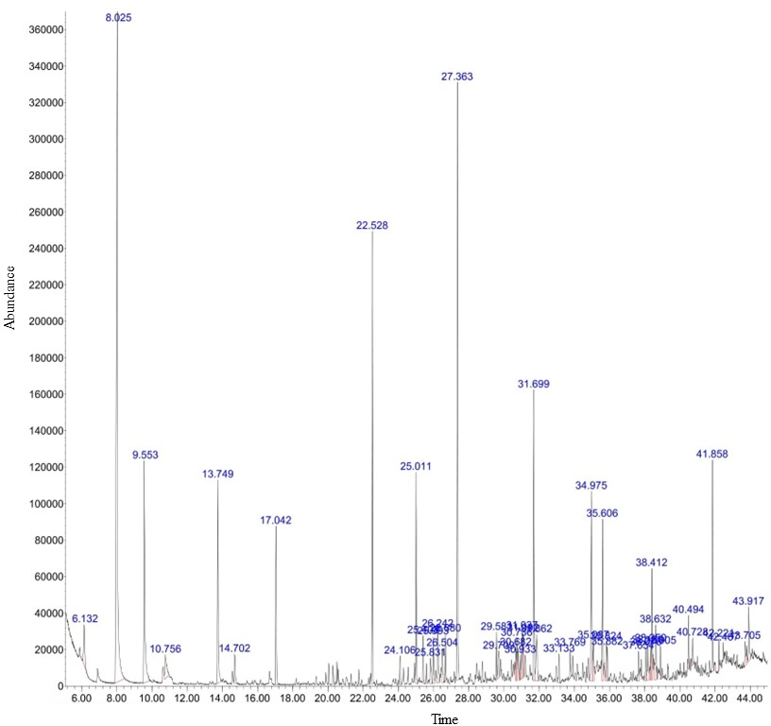**Supplementary Fig. S1**. Chromatogram of the identified compounds extracted from *Irpex laceratus* G.f. using n-hexane solvent. The x-axis represents the retention time (min), while the y-axis indicates the abundance of detected signals. Peaks (displayed in blue) represent the detected compounds, labeled according to their respective retention times from left to right.

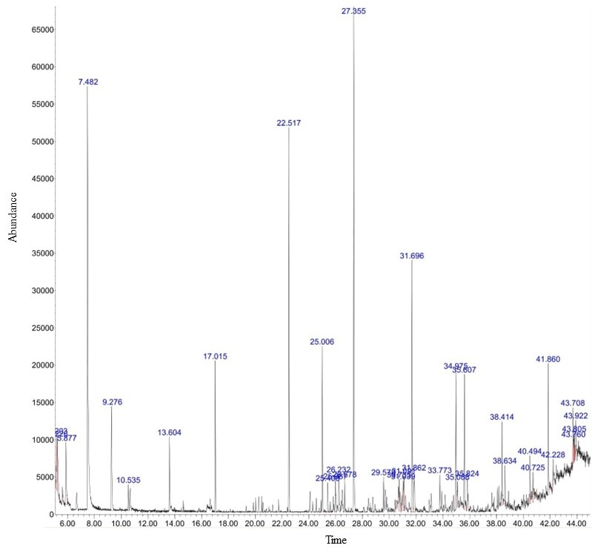

**Supplementary Fig. S2**. Chromatogram of the identified compounds extracted from *Irpex laceratus* G.f. using n-butanol solvent. The x-axis represents the retention time (min), while the y-axis indicates the abundance of detected signals. Peaks (displayed in blue) represent the detected compounds, labeled according to their respective retention times from left to right